Live Chat Support System — Principal Architecture Design

Architecture Pattern: Serverless + Event-Driven + Hybrid AI
Domain: Healthcare (HIPAA-Aligned) · Member Support · Real-Time Chat
Target Scale: 100K–1M concurrent members · 10x traffic spikes during open enrollment

Executive Summary
- Problem: Aetna needs a modern, scalable member support system that handles unpredictable healthcare volumes (10x spikes during open enrollment), protects sensitive health data (HIPAA), and reduces operational costs through intelligent automation (bot resolution 65–70%).
- Solution: Event-driven serverless architecture combining Amazon Lex V2 (intent-based NLU) + Amazon Kendra (RAG-style knowledge retrieval) with live agent escalation. WebSocket API for sub-100ms real-time chat, multi-AZ Aurora + DynamoDB for reliability, and comprehensive audit logging for compliance.
- Key Design Decisions: (1) WebSocket over polling for latency, (2) Intent-based + RAG hybrid for accuracy, (3) Event-driven for extensibility, (4) Managed services (Lex, Kendra, Lambda) for fast time-to-market with low ops burden.
- Business Outcomes: 99.95% availability · <100ms p50 latency · 65–70% bot resolution · $0.05–$0.10 cost per chat · Full HIPAA compliance with 7-year audit trail.

High Level Requirement

Functional
Member Chat Interface — Initiate chat, send/receive messages in real-time, receive typing indicators, escalate to agent, rate resolution.
Chatbot Engine — Understand member intents (e.g., "What's my claim status?", “What are my plans benefits”), extract context (claim ID, member ID), query Aetna systems, retrieve from knowledge base, respond naturally.
Agent Escalation — Route to available agent based on skill match and utilization, preserve full chat context, enable warm handoff (agent can see prior messages and bot diagnosis).
Agent Desktop — Accept/reject chats, view member profile + context, respond to multiple concurrent chats (50 max), transfer to specialist, close and rate resolution.
Admin Dashboard — Supervisor monitoring (real-time agent status, queue depth, SLAs), analytics (resolution rate, CSAT, cost per chat), chat history search, coaching notes.

Non-Functional
Requirement | Target | Justification
Availability | 99.95% uptime | Healthcare support is critical; member expectations align with telehealth SLAs.
Latency (p50) | <100ms | Real-time conversation feel; polling would be 5–30s unacceptable.
Latency (p99) | <2s | Acceptable for knowledge base queries or escalation routing.
Concurrency | 100K–1M simultaneous connections | Open enrollment periods (3 months) see 10x traffic spikes.
Bot Resolution Rate | 65–70% | Reduces agent load; improves member satisfaction for routine queries.
Cost per Chat | $0.05–$0.10 | At 1M chats/month, cost-effective vs. dedicated agent-only model.
RTO (Disaster Recovery) | <5 minutes | Healthcare domain; member experience disruption unacceptable.
RPO (Data Loss) | <5 minutes | Audit logs and chat history are critical for HIPAA compliance.
Data Retention | 7 years | HIPAA requirement for member health records.

Compliance & Security Requirements
HIPAA Compliance: All member health data (names, claim IDs, SSN, diagnoses) encrypted at rest (AES-256) and in transit (TLS 1.3). Field-level encryption for PII. Comprehensive audit logging of all access (WHO, WHEN, WHAT).
Data Residency: All production data must remain in US AWS regions (no cross-border transfer). Compliant with Aetna security standards and HIPAA BAA requirements.
Aetna IdP Integration: Members authenticate via existing Aetna identity provider (OIDC). Agents authenticate via corporate AD/SSO. No separate user database.
Audit Trail: Immutable log of every chat message, escalation decision, agent action. Must be retained 7 years and searchable for compliance audits.

Layered Architecture
Layer | Components | Primary AWS Services | Responsibilities
1. Frontend | React SPA · React Native Mobile | S3 · CloudFront | User interface, message display, real-time UI updates
2. Edge Security | CDN · WAF · Identity | CloudFront · WAF · Cognito | DDoS mitigation, HTTPS termination, user authentication
3. API Gateway | WebSocket API · REST API | API Gateway | Route messages, handle connections, authorize requests
4. Compute (Serverless) | Lambda functions | Lambda · SQS DLQ | Business logic: message routing, bot/agent logic, escalation
5. Data Cache | Session store, member context | Redis | Sub-5ms context retrieval, agent presence, session TTL
6. Persistence | Operational DB, NoSQL, S3 | Aurora · DynamoDB · S3 | Long-term storage, audit logs, chat history
7. Event Bus | async messaging, analytics, notifications | EventBridge · SQS · SNS · Kinesis Firehose | Decouple services, enable extensions, audit trail

High Level System Design

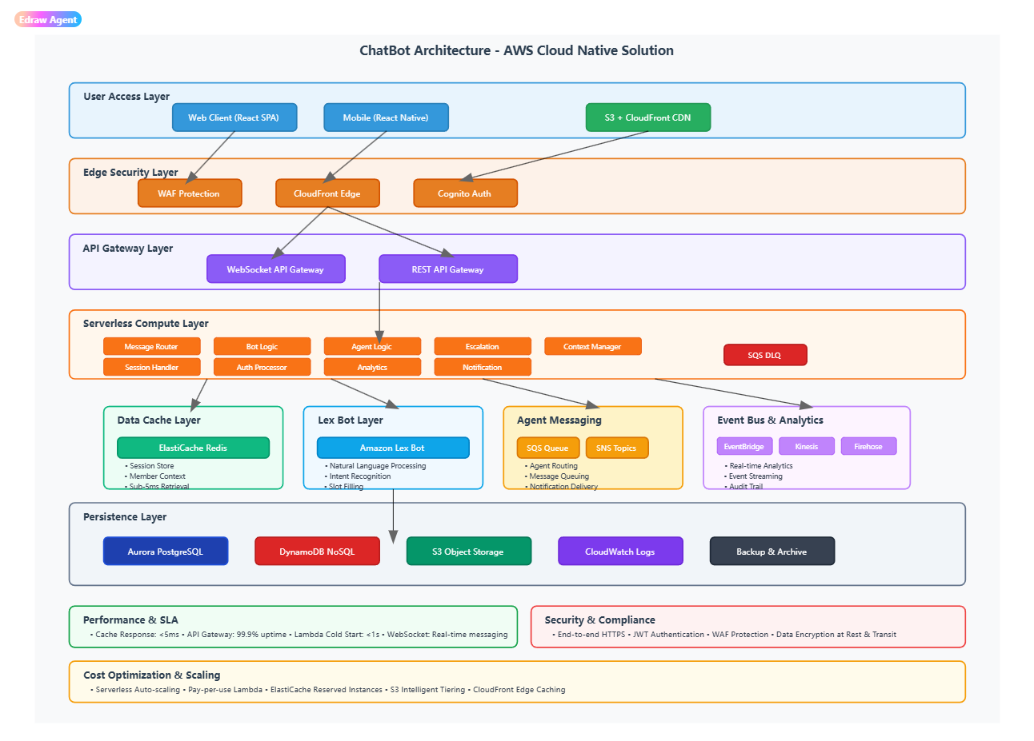
Detail Layered design (see the Pdf).

Data Flow

Happy Path -- Bot Resolves
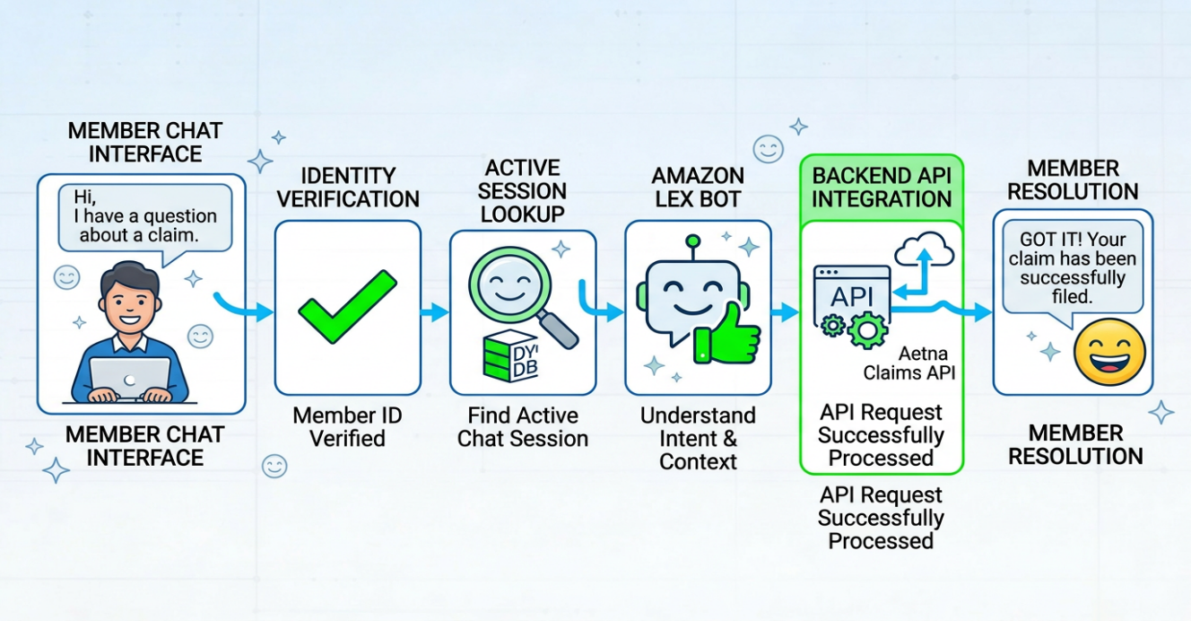
- Member types a message
- Identity is verified
- Session is looked up for any active session
- Lex understands the question
- Backend API’s are called (e.g. Aetna Claims API)
- Response sent to member

Async Call (Audit, Analytics, Survey, Training Loop)
After member receive the response, all the data will be persisted in parallel quietly behind the scene.
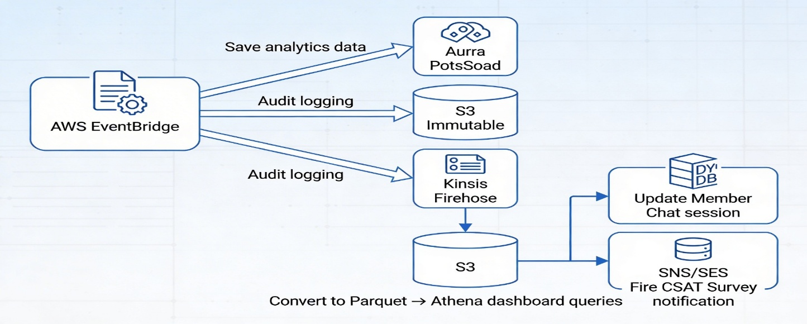
- Event is published to EventBridge
- EventBridge sends the event to
  - Save the message to the database for analytics in Aurora PostgreSQL.
  - Write the audit log to Amazon s3 (Immutable).
  - Stream raw event to S3 using Kinesis Firehose in Parquet Format, to update the Dashboard (Athena Queries)
  - Close Member Chat session (DynamoDB Update) and to Fire CSAT Survey (email or Notification)

Escalation Path — Low Confidence
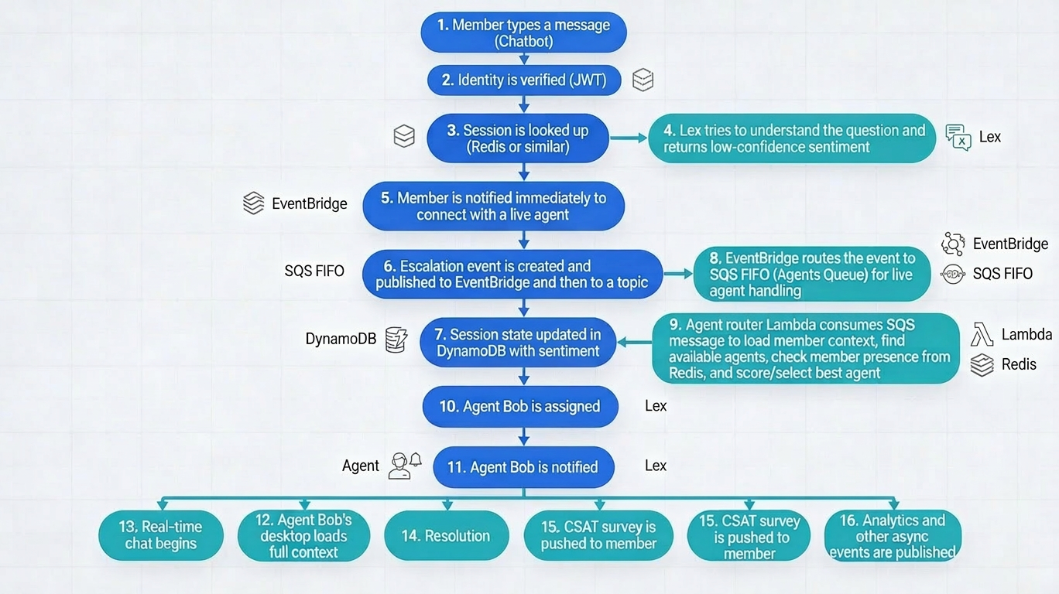
- Member types a message (Chatbot)
- Identity is verified (JWT)
- Session is looked up (Redis or similar)
- Lex tries to understand the question. (Message sent to Lex) returns the sentiment
- Member is notified immediately. (Message returns to member to connect with live agent)
- Escalation event is created and published to EventBridge and eventually to topic
- Session state is updated. DynmoDB session details are updated to record the sentiment
- EventBridge routes the event to SQS FIFO. Publish the event to Agents Queue to be handled by Live Agent.
- Agent router Lambda picks up the SQS message to
- Load member context
- Find available agents
- Check live presence of member and load from Redis
- Score and pick the best agent.
- Agent Bob is assigned
- Agent Bob is notified
- Agent Bob's desktop loads full context
- Real-time chat begins
- Resolution
- CSAT survey is pushed to member about the experience.
- Analytics event is published (async) and other async events and messages are created as mentioned above.

Auth Flow
Objective: Who is calling the system and how to identify the user is valid.
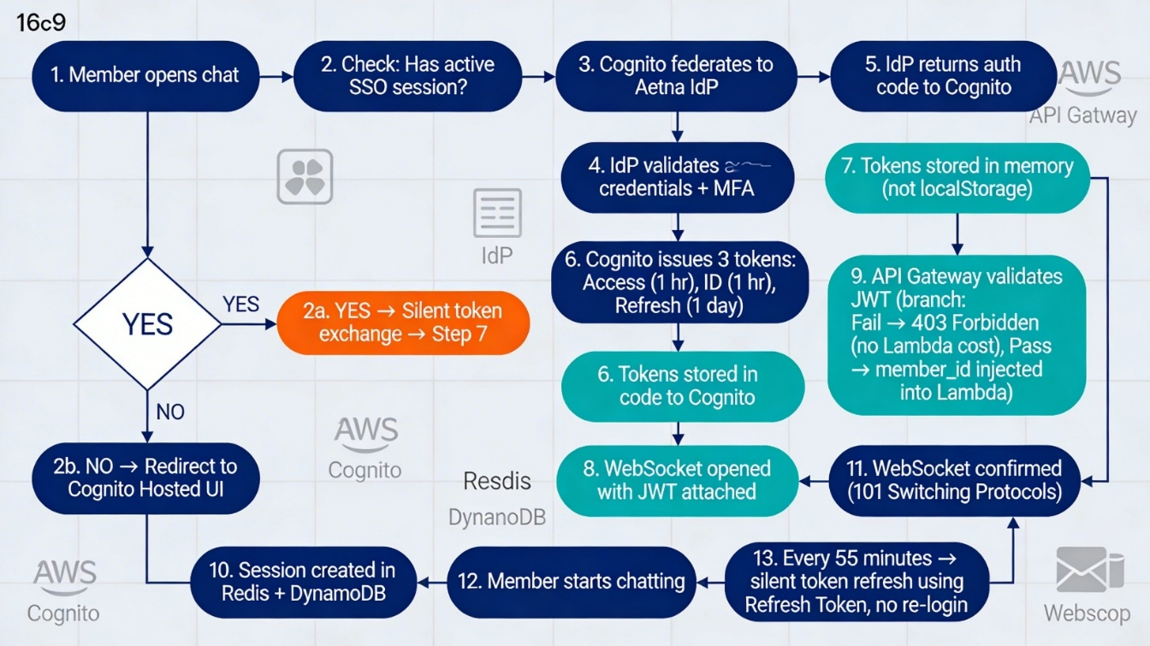
- Member opens chat
- Has active SSO session?
  - YES → Silent token exchange → Step 7
  - NO → Redirect to Cognito Hosted UI

- Cognito federates to Aetna IdP
- IdP validates credentials + MFA
- IdP returns auth code to Cognito
- Cognito issues 3 tokens:
  - Access (1hr) + ID (1hr) + Refresh (1d)
- Tokens stored in memory (not localStorage)
- WebSocket opened with JWT attached
- API Gateway validates JWT
  - Fail → 403 Forbidden (no Lambda cost)
  - Pass → member_id injected into Lambda
- Session created in Redis + DynamoDB
- WebSocket confirmed (101 Switching Protocols)
- Member starts chatting
- Every 55 minutes → silent token refresh. (Refresh Token used, no re-login needed)

The Learning Cycle (Training Pipeline)
The chat generates the data (happy path and Escalation) which can be used make the bot smarter to reduce the HITL. The escalation path data can be a key factor to help system in improving over the time and to reduce manual intervention.
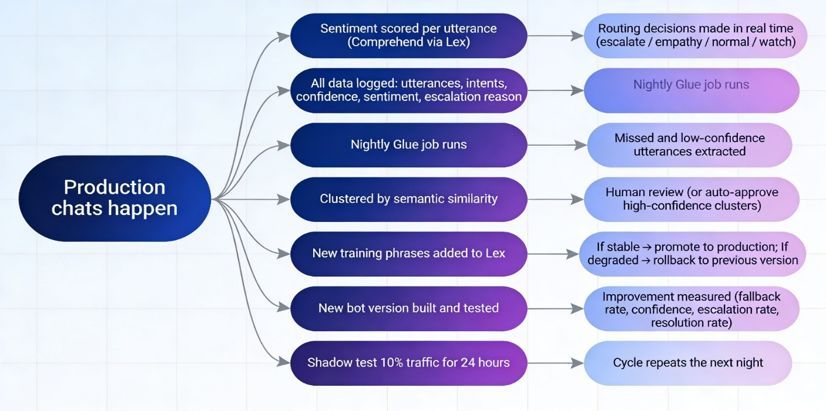

Resilience Patterns — Multi-Layer
Pattern | Implementation | Recovery
Multi-AZ Active | Lambda, Aurora, DynamoDB, ElastiCache across 3 AZs | AZ failure: automatic, < 30s
Multi-Region Warm Standby | Aurora Global DB, DynamoDB Global Tables, S3 CRR, Route53 failover | Region failure: RTO < 5 min, RPO < 5 min
Circuit Breaker | Lambda retry config + fallback: bot unavailable → route to agents | Service outage: seamless degraded mode
Dead Letter Queue | SQS DLQ on all Lambda async invocations and EventBridge rules | No message loss; replay after fix
Bulkhead | Separate Lambda concurrency limits per service function | One noisy service can't starve others
Database PITR | Aurora + DynamoDB Point-in-Time Recovery | Data corruption: restore to any point in 35 days

Scalability — Layer by Layer
Layer | Service | Scaling Mechanism | Peak Capacity
Edge | CloudFront | Global edge PoPs, auto-scales transparently | Unlimited
API | API Gateway | 10K RPS burst limit (configurable) | 10K+ RPS
Compute | Lambda | Concurrency auto-scales; provisioned for hot paths | 1000+ concurrent
Chatbot | Lex V2 | Managed, scales with Lambda invocations | Auto
Queue | SQS / EventBridge | 1M+ messages/sec, managed service | Unlimited
Session DB | DynamoDB | On-demand capacity; scales 0→100K writes/s | 100K+ writes/s
Cache | ElastiCache | Cluster mode sharding, read replicas | Sub-5ms at scale
Relational | Aurora | Read replicas auto-scale (Aurora Serverless v2 option) | Multiple read replicas

Security — All Levels (Perimeter → Data)
Level | Layer | Controls
L1 – Edge | CloudFront + WAF + Shield | DDoS mitigation, OWASP rules, geo-restriction, rate limiting, TLS 1.3
L2 – Identity | Cognito + Aetna IdP | OIDC federation, JWT RS256, MFA, RBAC (member/agent/supervisor/admin)
L3 – Network | VPC + Security Groups + NACLs | Lambda in private subnets, VPC endpoints (no public DB), NACLs, flow logs
L4 – Application | Lambda IAM + API Gateway | Least-privilege per function, API key validation, input validation, no wildcard policies
L5 – Data in Transit | TLS / WSS | TLS 1.3 enforced, HSTS header, ACM managed cert auto-renewal, WSS only
L6 – Data at Rest | KMS CMK + AES-256 | Separate CMKs per service, 90-day rotation, field-level encryption for PHI/PII
L7 – Audit & Detection | CloudTrail + GuardDuty + Macie | Immutable CloudTrail logs, anomaly detection, PII auto-discovery on S3, alerts via SNS
L8 – Compliance | Security Hub + Config + BAAs | HIPAA control mapping, drift detection, BAAs with AWS + third parties, penetration testing

Addendum

Agent Journey
- Login & status: Agent signs into the Agent Desktop with corporate SSO (Cognito federated to Aetna IdP) and sets their status to 'Available'. Presence is stored in Redis for low-latency lookups.
- Queue view: The console shows skill-based queues and the agent's active chats. Supervisors can see real-time metrics such as queue depth and SLA risk.
- Incoming chat: When the router assigns a chat, the agent sees a toast notification. Accepting opens the full thread with member context already loaded.
- Handling multiple chats: The UI supports multiple concurrent chat tabs with clear indicators for new messages, typing status, and SLA timers per chat.
- Transfers & collaboration: Agents can transfer a chat to a specialist queue or invite a supervisor into the thread, with all history preserved.
- Wrap-up: At the end, the agent selects resolution codes, adds internal notes, and optionally marks chats for training review (e.g., good examples, problematic flows).

Conclusion & Key Outcomes
This design delivers a serverless, event-driven, hybrid AI live chat platform that meets Aetna’s business, technical, and regulatory goals. It uses Amazon Lex V2 and Kendra behind secure WebSocket APIs to provide sub-100 ms real-time chat on web and mobile, resolving 65–70% of routine inquiries and seamlessly escalating low-confidence cases to agents with full context in an Agent Desktop and supervisor dashboard.

